## Quotation Summary

Quotation No: ORBIT/2025/1/{{receipt_no}} Date: {{date}}

Customer Name: {{customer_name}}

Address: {{address_line1}}

Phone Number: {{phone}}

Email (if available): {{email}}

**Quotation Details:**

Total Price: {{total_price}}

Subsidy Applied: {{subsidy}}

Subsidised Price (All Inclusive): {{final_price}}

**Authorised Signatory**

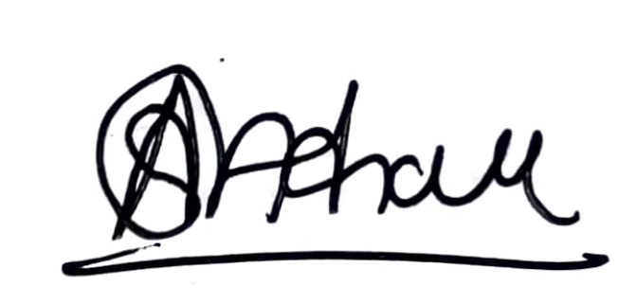

For Higher Orbit Agritech Pvt. Ltd.

|  |  |
| --- | --- |
| **Item Name** | **Quantity** |
| 12 HP PT Pro | {{quantity_pt_pro}} |
| Battery Sets | {{quantity_battery}} |
| Fast Chargers | {{quantity_charger}} |
| 1 Set of Sugarcane Blades (Weeding) | {{quantity_blade_weeding}} |
| 1 Set of Sugarcane Blades (Earthing-up) | {{quantity_blade_earthing}} |
| 1 Set of Tyres (5x10) | {{quantity_tyres}} |
| Toolkit | {{quantity_toolkit}} |
| Ginger Kit | {{quantity_ginger}} |
| Seat | {{quantity_seat}} |
| Jack | {{quantity_jack}} |
| BuyBack Guarantee | {{quantity_buyback_guarantee}} |
| Front Dead Weight | {{quantity_front_dead_weight}} |
| Wheel Dead Weight | {{quantity_wheel_dead_weight}} |